CLARENDON ROAD
PRIMARY SCHOOL



ATTENDANCE
POLICY

Approved by: |  | Date:
Last reviewed on: | December 2024
Next review due by: | December 2025
Introduction
Clarendon Road Primary School is proudly recognised as an Inclusive Attendance school. Our unwavering commitment to attendance centres around child-centric actions, evidence-informed practices, taking into account the pupil & parent voice and a shared understanding of everyone's roles and collective responsibilities to promote exceptional attendance.

Inclusive Attendance Professional Development Model
The Inclusive Attendance professional development model fundamentally guides our attendance approach. Comprising six tailored Learning Modules, this model empowers us to deepen our understanding by facilitating continuous professional learning for all staff. Within this model, the four domains of practice ensure the provision of professional learning, professional development, evidence-based practices, and exemplary leadership and management to seamlessly integrate theory into practice.

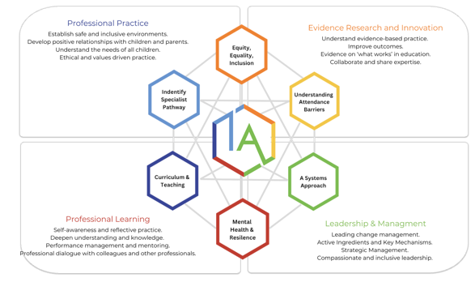

Annual Inclusive Attendance 7-Month Development Programme
Each year, Clarendon Road Primary School will review and further enhance attendance practices through dedicated participation in the Inclusive Attendance 7-month development programme. This investment allows us to remain at the forefront of educational change and extends unparalleled support to our children and their families, equipping them with access to the finest possible assistance.

A Multi-Tiered System of Support
To guarantee a comprehensive approach to attendance, Clarendon Road Primary School will implement a Multi-Tiered System of Support. A Multi-Tiered System of Support (MTSS) for school attendance involves three tiers of intervention, with roles for teachers, the school, children, parents, and external agencies – including the Local Authority. Data-driven decision-making and training requirements are pivotal to the implementation of this system. The system aligns with the Department for Education's (DFE) "Working Together to Improve School Attendance" statutory paper 2024.

Tier 1 - Universal Approach: Establishing a baseline universal attendance approach that benefits all children.

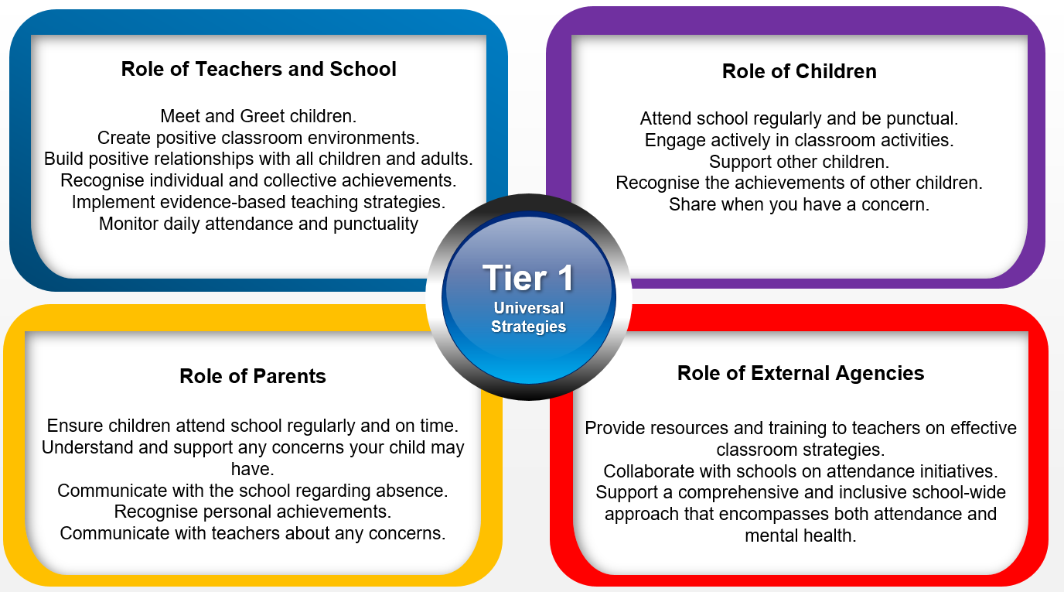

Tier 2 – Internal individualised Strategies and Early Help Support: Tailoring strategies to individual needs and providing early help support for persistent attendance challenges.

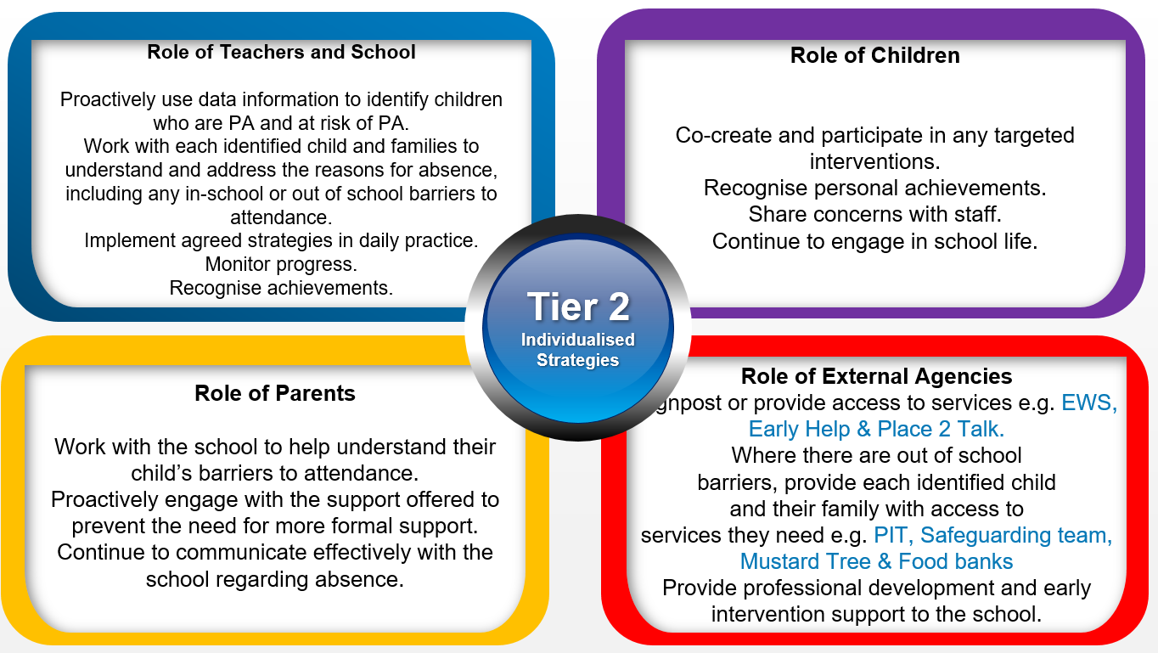
Tier 3 - Higher Needs Strategies Support: Furnishing specialised support for children, young people, and families with complex attendance requirements, including access to external agency support when necessary.
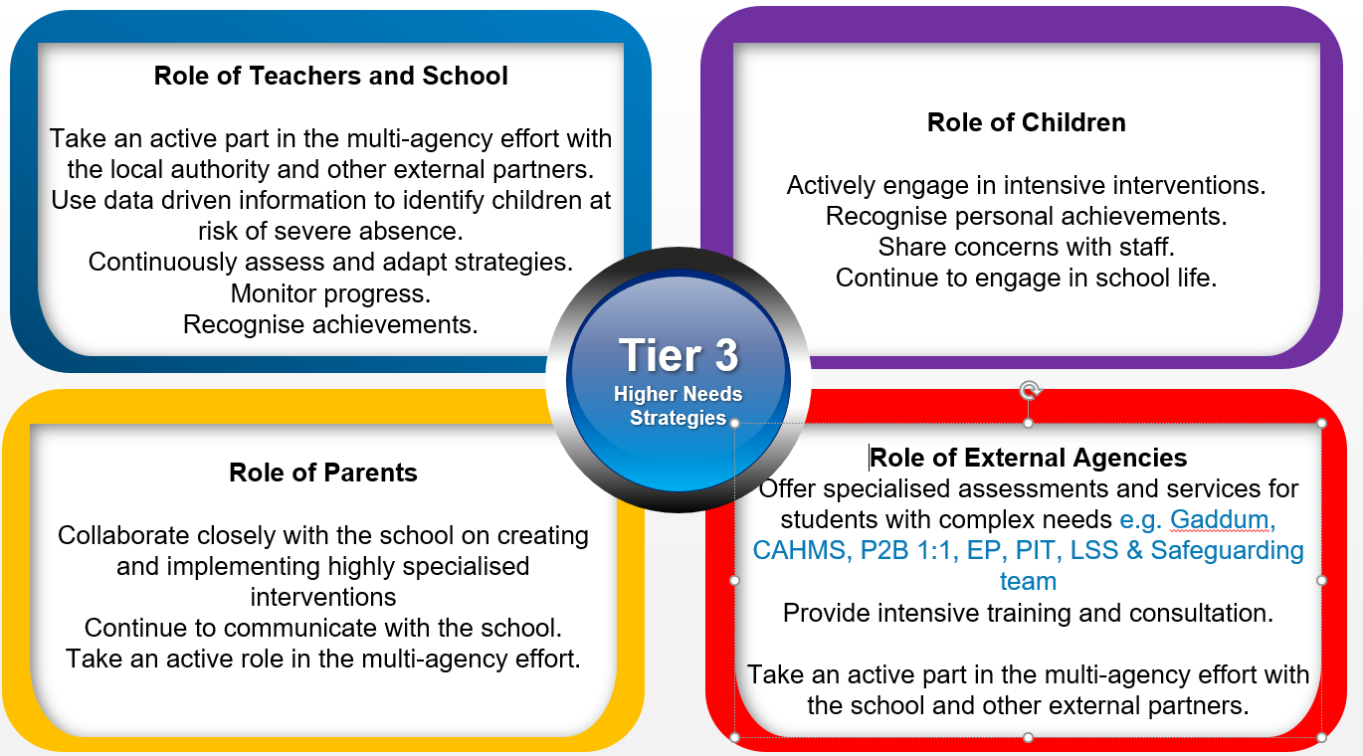

Clarendon Road Primary School Recognition-Based Approach
Our attendance philosophy is rooted in a recognition-based approach that recognises both personal and collective achievements. This approach serves to thwart isolation, prevent victimisation, cultivate positive environments, nurture relationships, foster inclusivity, and ultimately cultivate intrinsic motivation among our children, families, and staff.

Our recognition-based approach has developed in consultation with pupil and parent voice. This whole school initiative awards purple attendance slips, on a weekly basis, to children who have maintained or improved their attendance based on the previous week. Purple attendance slips are awarded by the class teacher in a low-risk environment on a Friday afternoon. Slips are placed in the star slip box, thereby providing children with more chances to be recognised at star slip assembly on a half-termly basis.

The Importance of School Attendance at Clarendon Road Primary School
School attendance is not merely a requirement but a fundamental pillar of education. It plays a pivotal role in shaping academic success, personal growth, and future prospects, making it an indispensable aspect of any educational system. Regular attendance to school can have a significant impact on:

- Academic Achievement: Regular attendance directly correlates with academic success. Children who attend school consistently are more likely to keep up with the curriculum, perform better in assessments, and improve their life outcomes.
- Knowledge Acquisition: School is where children acquire knowledge and skills that are crucial for their personal and professional growth. Missing days means missing out on valuable learning opportunities.
- Social Development: School provides a vital social environment for children and adolescents to interact with peers, develop friendships, and learn essential social skills. Consistent attendance ensures children remain connected to their peer group.
- Building Routine: School attendance establishes a structured routine in children’s lives, teaching them time management and responsibility, which are valuable life skills.
- Teacher Interaction: Regular attendance allows for meaningful teacher-child interactions. Teachers can provide personalised support, address questions, and assess individual progress more effectively when children attend regularly.
- Preventing Knowledge Gaps: Frequent absences can lead to significant knowledge gaps, making it challenging for children to catch up with missed lessons, potentially resulting in long-term academic struggles.
- School Engagement: Children who attend school regularly are more likely to engage in extracurricular activities, sports, and other enriching experiences that contribute to their overall development.
- Legal and Parental Responsibility: Parents or guardians are legally responsible for ensuring their child's regular school attendance. Failing to do so can lead to legal consequences.
- Community Well-being: High levels of school attendance contribute to the overall well-being of communities.

Factors Influencing Attendance
There are many factors, which can affect a child attending school. In consultation with pupil and parent voice in May/June 2024, Clarendon Road has identified the following factors. If you have any concerns, you should contact the school as soon as possible:

Health Issues: Children may experience physical or mental health issues that lead to absences. Chronic illnesses, infections, and mental health conditions can impact a student's ability to attend school regularly.

Family Circumstances: Family-related factors such as bereavement, family illness, or caring responsibilities can result in absences from school. In some cases, students may need to take time off to support their families.

Safety Concerns: Experiences of bullying, harassment, or safety concerns at school can deter students from attending. They may fear for their safety or well-being, leading to increased absenteeism.

Transportation Issues: Difficulty in accessing transportation to school, especially in rural areas, can affect attendance. Lack of reliable transportation options can lead to sporadic attendance.

Socioeconomic Factors: Families facing financial difficulties may struggle to provide necessary resources for their children to attend school regularly. Issues such as lack of appropriate clothing, food, or a stable home environment can contribute to absenteeism.

Special Educational Needs (SEN): Students with special educational needs may require additional support and accommodations to attend school regularly.

Engagement and Motivation: Lack of engagement with school activities and a perceived lack of relevance in the curriculum can lead to disinterest in attending. Children who are not motivated may avoid attending school.

Cultural and Language Barriers: Children from diverse backgrounds may face challenges related to language barriers or cultural differences. These challenges can affect their attendance and engagement with school.

Social Factors: Influence from peers can impact attendance. Children may avoid attending school to align with the behaviour of their peers or to engage in social activities outside of school.

Parental Involvement: Parental support and involvement in a child's education can positively influence attendance. Lack of parental engagement may lead to increased absenteeism.

Supporting Attendance at Clarendon Road Primary School
To address any identified attendance issues effectively, Clarendon Road Primary School implements a range of strategies such as early intervention, support for vulnerable families, intervention programmes, and creating a positive and inclusive school environment. Understanding the specific factors affecting attendance for individual children and families is crucial for developing any targeted interventions and support systems to improve attendance outcomes.

Attendance and Punctuality Expectations at Clarendon Road Primary School
Children are expected to attain 100% attendance.
Children are expected to attain 100% punctuality.

Contact Details of School Staff at Clarendon Road Primary School

Name of Staff Member | Roles and Responsibilities | Contact Details
Philip Lowry | Attendance Champion | 0161 921 1170
Lauren Wood | Attendance Manager/Officer | 07855962423
Rachel Gallagher | Safeguarding Lead (DSL) | 0161 921 1170
Faye Allison | Governor for School Attendance. | 0161 921 1170

How we use data to support attendance
• Analysing whole school cohort and individual year groups.
• Individual pupils.
• Demographic groups e.g., pupils from different ethnic groups or economic backgrounds.
• Other groups of pupils e.g., pupils with SEND, CFC, and pupils eligible for FSM.
• Pupils who have an allocated social worker or are known to social care.
• A pupil who is absent for prolonged periods, or repeated occasions, which may indicate a safeguarding concern, such as CSE or CRE, particularly county lines.
• Pupils at risk of PA.
• Pupils at risk of SA.

Strategy for Reducing Persistent and Severe Absence at Clarendon Road Primary School
Individual Action Plans for SA
PA Strategy

Details of the National Framework for Penalty Notices at Clarendon Road Primary School

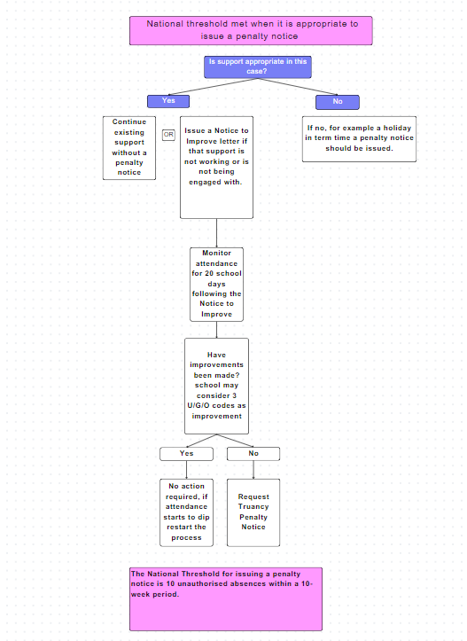

Where initial support is not successful in improving attendance
Part of this work may include creating an attendance contract. An attendance contract is a formal agreement between parents and the school or local authority to address irregular attendance, providing support as an alternative to prosecution. It is not legally binding but serves as a formal route to secure engagement with support when voluntary early help plans have not worked. An attendance contract aims to offer support rather than punishment.

If voluntary support or attendance contracts are unsuccessful, an Education Supervision Order (ESO) can provide formal legal intervention without prosecution. Before proceeding with an ESO, the school and local authority should exhaust voluntary support options and ensure the order would benefit the pupil and parent. Persistent non-compliance with an ESO can lead to prosecution in the Magistrates Court by the local authority. Upon conviction, parents may face fines of up to £1,000.

Local authorities have the power to prosecute parents for various offences related to attendance:
Failure to comply with a school attendance order may result in fines of up to £1,000. Failure to secure regular attendance at school or alternative provision may lead to fines of up to £2,500 and/or imprisonment. Persistent non-compliance with an Education Supervision Order may result in fines of up to £1,000.

Removal from roll
This refers to the process of a child’s name being officially taken off the school's register, typically due to extended non-attendance or other circumstances. Elective Home Education (EHE) is an option that some parents choose after removal from roll, where they take responsibility for providing education to their child at home.

Day-to-Day Processes for Managing Attendance at Clarendon Road Primary School

PROCEDURES AND INTERVENTION TECHNIQUES
We adopt a whole school approach, which reinforces good attendance. This includes:
- An Attendance Policy, which is easily understood by all and regularly updated and shared with all stakeholders.
- Appropriate attendance targets.
- The Attendance Champion monitoring attendance weekly.
- Close working relationships with our Attendance Support Officer who will carry out home visits, without prior notification to pupils whose attendance is a concern/unexplained.
- Panel meetings for persistent absentees, held by the Attendance Support Officer and the Attendance Champion which may involve other support services where necessary.
- Weekly reporting of attendance issues to the senior management team and half termly to the FGB.
- A multi-agency response to improve attendance and support pupils/families.

Information being shared regularly with parents through leaflets, letters and parents evenings reminding them of their responsibility for ensuring their children’s regular attendance, including their punctual arrival at school and of the potential sanctions for failure to meet their responsibilities (eg Penalty Notices).
- Explaining the link between poor attendance and reduced attainment.
- Providing information about the range of support services that parents can access
- Using school assemblies and visual displays to engage pupils

Register Procedures
- The register is completed by the teacher on INTEGRIS and sent to the office electronically at 8.45am.
- Children arriving late are registered by parents via the Inventry sign-in system.
- In the event of a fire/fire drill, the admin team bring paper registers out and distribute to teachers.

Office Register Procedures
- Register and update contact information from parents at least annually.
- Update contact information.
- Update registers daily (including late children).
- Safeguard registers during the school day.
- Be responsible for the distribution of registers in the event of a fire/fire drill.
- Contact families when children are absent from school through ‘1st Day Response’ System.
  - Day One: Text Message sent to 1st contact for an absent child. If no response by 2pm - follow it up with a phone call.
  - Day Two: Telephone call to 1st contact.
  - Day Three: Further telephone call. If no response, message or email sent home. (Home visit considered).

Attendance Champion
- Provide attendance figures for the headteacher and staff.
- Work directly with identified parents to bring about improvements.
- Liaise with the Attendance Support Officer (EWO).
- Update attendance data weekly by collecting data from the absence returns.
  - Individual target pupils
  - Reports to the Governing Board
  - Case conferences
- To monitor register procedures

ABSENCE PROCEDURES
We expect the parent/carer to make contact with school before 9.15am on each day to report that their child will be absent from school. The school has a first day response system in place in which the following happens:
- Day one: A phone call or a text message to the 1st contact for an absent child.
- If no satisfactory explanation is received the absence counts as unauthorised.
- Registration is the responsibility of the class teacher or teaching assistant and is done twice a day, at 8:45am and 1.00pm (12.30pm for EYFS.)
- The school actively discourages parents going on holiday in term time.

Following Salford City Council guidelines the Attendance Champion can issue the request of a penalty notice to parents in the following circumstances:
- For unauthorised holidays in term time (5 days/10 sessions or more absence).
- When a child has 10 unauthorised sessions, including unauthorised sessions recorded as a U code in the register, due to arriving late for school (after 9.15am) 1 day = 2 sessions.
HOLIDAYS IN TERM TIME
Parents are strongly urged to avoid booking a family holiday during term time. Parents have a legal duty to make sure that their child aged 5-16, if registered at a school, attends that school regularly and is consistently punctual.

The Government legislation does not give ANY entitlement to parents to take their child out of school during term time. Even if a child has good attendance, this will not be taken into consideration. Any absences will be marked as unauthorised unless they are deemed exceptional circumstances.

Requests for holidays in term time must be sent via ParentApp or email to the Headteacher. On receipt of the request, parents will be sent a response, indicating whether the school is able to authorise the leave of absence or not. If parents, contrary to the school refusing the request, still decide to take their child out of school for a leave of absence, then the absence will be coded as unauthorised, and a fixed penalty fine may be issued.

Under the legislation from DFE, holidays during term time are not permitted except in exceptional circumstances and under the discretion of the Headteacher. Unauthorised holidays taken during term time may result in a £60 fine per pupil per parent. If the fine is not paid within 21 days, the fine will increase to £160. IF A CHILD’S ABSENCE HAS BEEN RECORDED AS SICKNESS BUT IT IS LATER PROVEN THAT AN UNAUTHORISED HOLIDAY HAS TAKEN PLACE, A FINE CAN BE ISSUED AFTER THE CHILD RETURNS TO SCHOOL.

Should a holiday be taken when no written request has been made, a request for the implementation of a penalty notice will be made to the Local Authority.

Punctuality
Punctuality is vital to the education process. If your child misses the start of the day, they can miss work and do not spend time with their class teacher missing vital information and news for the day. This can significantly reduce achievement, regardless of academic ability. Pupils who arrive late also disrupt lessons, which can be embarrassing for the child and can in turn, encourage absence. Parents must take responsibility for getting children to school on time.

The doors open at 8.30am and close at 8:40am. The start of the school day is 8.45am. Children arriving after 8.40am must enter through the main entrance, where their parent/carer will have to sign in at reception, and offer reasons for lateness. Children must be accompanied to the office by an adult if late.

Registers are marked by 8.45am and children will receive a late mark (L) if they are not in by that time.

In accordance with the regulations, a pupil arriving after the register has closed at 9.15am is marked absent with code U, or with another absence code if that is more appropriate. This may mean that parents face the possibility of a Penalty Notice if the problem persists.

Persistent latecomers will be referred to the Attendance Support Officer.

Taking Children Out During School Day
Children have permission to leave school during the day for an appointment that cannot be made at any other time, e.g. hospital. Parents must report to the office prior to collecting their child, providing proof of appointment. If the child returns following an appointment they must be signed back in. FAILURE TO PRODUCE MEDICAL EVIDENCE WILL RESULT IN AN UNAUTHORISED ABSENCE.

School Times of the Day at Clarendon Road Primary School
The school day begins at 8:30am and ends at 3:15pm (3:05pm for EYFS)

Registration opens at 8:40am and closes at 8:45am.

Children are expected to arrive on time and attend all scheduled lessons and activities.

Coding of Attendance
Attendance will be recorded using the DFE's statutory attendance codes, please refer to the appendix for coding.

Requesting Absence Leave
Parents or carers must request leave of absence for their child in writing at least five school days in advance.
Leave of absence during term time will only be authorised in exceptional circumstances.

Safeguarding children and attendance at Clarendon Road Primary School
The school has a duty to safeguard the welfare of all students. Any concerns about a child's attendance will be investigated promptly to ensure their well-being.

Unexplained or extended absences will trigger safeguarding procedures, including home visits and communication with relevant agencies.

We follow Keeping Children Safe In Education guidance to ensure safe practices.

Review
This Attendance Policy will be reviewed annually by the school's governing body to ensure its effectiveness and compliance with statutory requirements. Any amendments will be communicated to staff, parents, and carers as necessary.

Appendices

Appendix 1 – Definitions
In the context of school attendance and education in the UK, the terms "Persistent Absence," "Risk of Persistent Absence," and "Severe Absence" are used to describe different levels of irregular attendance by students. These terms are important for tracking and addressing attendance issues.

Persistent Absence (PA):

Definition: Persistent Absence is a term used to describe a level of student absence from school that is considered to be a significant cause for concern.

Threshold: In England, a student is considered to be persistently absent when they have an attendance rate of 90% or below. This means they have missed 10% or more of their school sessions.

Risk of Persistent Absence:
Definition: The term "Risk of Persistent Absence" refers to a situation in which a student's attendance is at a level that suggests they are at risk of becoming persistently absent.

Threshold: While there is no specific threshold for "Risk of Persistent Absence," it is typically used to describe students whose attendance is consistently low and becoming a concern, as the school communicates to parents in days, we identify 10 days or more as Risk of PA and we will follow internal school procedures.

Severe Absence (or Severe Persistent Absence):
Definition: The term "Severe Absence" or "Severe Persistent Absence" is used to describe the most serious cases of non-attendance.

Threshold: Particular focus and support will be provided to pupils who are absent from school more than they are present (those missing 50% or more of school). These severely absent pupils may find it more difficult to be in school or face bigger barriers to their regular attendance and as such are likely to need more intensive support across a range of external agency partners.

Absence Definitions
• Arrival at school after the register has closed.
• Not attending school for any reason.

Authorised Absence
• An absence for sickness for which the school has granted leave.
• Medical or dental appointments, which unavoidably fall during school time, for which the school has granted leave (evidence is required for all appointments).
• Religious or cultural observances for which the school has granted leave
• An absence due to a family emergency (at school’s discretion).

Unauthorised Absence
• Parents keeping children off school unnecessarily or without reason.
• Truancy before or during the school day.
• Absences which have never been properly explained..
• Arrival at school after the register has closed.
• Absence due to shopping, looking after other children or birthdays.
• Absence due to day trips and holidays in term-time, which have not been agreed.
• Leaving school for no reason during the day.

Appendix 2 – Policies & Practice
This attendance policy operates within the framework of statutory attendance regulations outlined in the Education (Pupil Registration) (England) Regulations 2006 and subsequent amendments. Clarendon Road Primary School will adhere to the following key attendance acts in the UK:

Education Act 1996: The Education Act 1996 is the primary piece of legislation that sets out the legal framework for school attendance in England and Wales. It outlines the responsibilities of parents, carers, and schools in ensuring regular school attendance. Sections 444-447 of the Act deal with offenses related to non-attendance and penalties for parents and carers.

Education (Pupil Registration) Regulations 2006: These regulations specify the procedures for registering pupils and maintaining attendance records in schools in England. They also define the circumstances in which a pupil can be marked as absent or present.

Education (Pupil Registration) (England) (Amendment) Regulations 2013: These regulations amended the 2006 regulations and introduced stricter rules on authorizing term-time holidays. Under these regulations, headteachers are only allowed to grant leave of absence in exceptional circumstances.

School Attendance Code of Practice: The School Attendance Code of Practice provides guidance to schools, local authorities, and parents on the law and procedures relating to school attendance and absence. It sets out the principles for promoting good attendance and dealing with poor attendance.

Local Authority School Attendance Guidance: Each local authority in the UK may provide its own guidance and policies on school attendance. Schools should be aware of and follow the specific guidance issued by their local authority.

Department for Education (DFE) Guidance: The DFE periodically issues guidance documents and updates related to school attendance. Schools should stay informed about the latest DFE guidance 2024 and follow any recommendations or requirements outlined in these documents.

Child Employment Legislation: Legislation such as the Children and Young Persons Act 1933 and the Children (Performances) Regulations 1968 govern the employment and attendance of children involved in performances, modelling, and other activities outside of regular school hours.

Children Missing Education (CME) Statutory Guidance: This guidance outlines the responsibilities of local authorities in identifying and tracking children who may be missing education, including those who are not on a school roll or are not receiving suitable education.

Section 19 of the Education Act 1996 (England and Wales) outlines the duty of local authorities in ensuring that suitable education is provided for children of compulsory school age.

Appendix 3 – Roles & Responsibilities

Attendance Champion: The role of an Attendance Champion in improving children's attendance in schools is critical in ensuring that students attend school regularly and achieve their educational potential. Attendance Champions have a multifaceted role that encompasses various responsibilities and strategies aimed at enhancing attendance rates.

Developing and Implementing Attendance Policies: Attendance Champions work closely with school leadership and staff to develop and implement effective attendance policies and procedures.

Data Analysis: Attendance Champions collect and analyse attendance data to identify trends and patterns. They use this information to pinpoint areas of concern, such as high levels of persistent absence, frequent lateness, or particular year groups or demographic groups with attendance challenges.

Early Intervention: Recognising that early intervention is crucial, Attendance Champions identify children at risk of poor attendance. They collaborate with teachers, parents, and support staff to address attendance issues as soon as they arise.

Supporting Families: Attendance Champions work closely with parents and guardians to build positive relationships and engage them in improving their child's attendance. They may conduct home visits, organise meetings, and provide guidance on strategies to promote regular attendance.

Mentoring and Coaching: Some Attendance Champions offer mentoring or coaching to children with attendance problems. They help children understand the importance of attending school regularly and provide strategies for overcoming barriers.

Providing Resources: Attendance Champions may connect families with resources and services that can help alleviate attendance-related challenges, such as housing support, counselling, or healthcare services.

Monitoring and Reporting: Attendance Champions continuously monitor attendance records and report attendance data to school leadership, governing bodies, and local authorities as required. They ensure that accurate records are maintained.

Interventions and Incentives: Attendance Champions design and implement interventions and incentives to motivate children to attend school. This may include recognition for attendance, recognition programmes, or targeted interventions for specific groups of students.

Staff Training: Attendance Champions provide training to school staff on effective attendance monitoring, reporting, and intervention strategies. They ensure that all staff members understand their roles in promoting attendance.

Legal Compliance: Attendance Champions are knowledgeable about legal requirements related to attendance, including regulations governing authorised and unauthorised absences. They ensure the school complies with these regulations.

Safeguarding: Attendance Champions are vigilant for safeguarding concerns related to attendance. They recognise signs of neglect or abuse and report them to designated safeguarding officers or authorities as necessary.

Community Engagement: Attendance Champions may collaborate with community organisations, social services, and local authorities to address attendance issues within the broader community context.

Continuous Improvement: Attendance Champions regularly evaluate the effectiveness of attendance strategies and interventions. They adapt their approaches based on data and feedback to achieve sustained improvements in attendance rates.

Promoting a Positive School Culture: Attendance Champions contribute to creating a school culture where attendance is valued, and students feel motivated and supported to attend regularly.

Governors/Trustees: School governors or trustees play a crucial role in supporting children's attendance in schools in the UK. Their responsibilities encompass strategic oversight, policy development, and ensuring that the school meets its statutory obligations regarding attendance.

Policy Development: Governors/trustees collaborate with school leadership to develop and review attendance policies. These policies should align with statutory requirements and provide clear guidance on attendance monitoring, reporting, and interventions.

Statutory Compliance: Governors/trustees ensure that the school complies with all relevant statutory requirements related to attendance. They are responsible for monitoring the school's adherence to attendance regulations.

Strategic Oversight: Governors/trustees take a strategic approach to attendance. They consider attendance as a key performance indicator and monitor trends and patterns in attendance data.

Monitoring Attendance Data: Governors/trustees review attendance data regularly to identify trends and areas of concern. They may request reports on attendance rates, persistent absence, and unauthorised absences.

Accountability: Governors/trustees hold school leadership accountable for attendance outcomes. They may question school leaders about their strategies for improving attendance and the effectiveness of interventions.

Policy Implementation: Governors/trustees ensure that attendance policies are effectively implemented throughout the school. They may inquire about the practical application of attendance policies and procedures.

Setting Targets: Governors/trustees collaborate with school leaders to set attendance targets and goals. They help establish benchmarks for improving attendance rates.

Reviewing Interventions: Governors/trustees assess the effectiveness of attendance interventions and strategies. They may request reports on the impact of interventions and whether they have led to improved attendance.

Parental Engagement: Governors/trustees support efforts to engage parents and guardians in promoting attendance. They may encourage the school to develop strategies for involving parents in attendance improvement initiatives.

Training and Development: Governors/trustees ensure that school staff, including teachers and support staff, receive training and development related to effective attendance monitoring and intervention strategies.

Safeguarding: Governors/trustees are vigilant for safeguarding concerns related to attendance. They work closely with the designated safeguarding lead to address any safeguarding issues that arise.

Community Links: Governors/trustees may establish links with community organisations, local authorities, and social services to access additional resources and support for students with attendance difficulties.

Challenge and Support: While supporting school leadership in attendance improvement efforts, governors/trustees also challenge when necessary. They ask probing questions and seek assurances that the school is taking appropriate action to address attendance issues.

Continuous Improvement: Governors/trustees regularly evaluate the school's approach to attendance and seek ways to continuously improve attendance outcomes.

Senior Staff: Senior staff at Clarendon Road Primary School play a critical role in supporting attendance for children. They provide leadership, set the tone for the school's attendance culture, and oversee the implementation of policies and strategies to promote regular attendance.

Leadership: Senior staff, including the headteacher/principal and deputy headteacher/vice principal, lead by example. They emphasise the importance of regular attendance and set high expectations for all staff and students.

Policy Development: Senior staff are responsible for developing, reviewing, and implementing attendance policies in line with statutory requirements. They ensure that policies are clear, effective, and communicated to all stakeholders.

Monitoring and Reporting: They monitor attendance data regularly, analysing trends and patterns. Senior staff use this data to identify students at risk of poor attendance and to measure the impact of attendance improvement strategies.

Setting Expectations: Senior staff establish clear expectations for staff regarding attendance monitoring, recording, and intervention. They ensure that staff understand their roles in promoting regular attendance.

Professional Development: They provide training and professional development opportunities for staff, including teachers, teaching assistants, and support staff, to enhance their knowledge and skills in attendance-related matters.

Early Intervention: Senior staff support early intervention efforts by identifying children with attendance issues and working with staff to implement targeted interventions. They ensure that appropriate support is provided to address attendance barriers.

Parental Engagement: They promote parental engagement in attendance improvement initiatives. Senior staff encourage open communication with parents and guardians and may organise meetings or workshops to involve parents in addressing attendance challenges.

Data Analysis: Senior staff use attendance data to inform decision-making. They set attendance targets and benchmarks for improvement and regularly review progress toward these goals.

Supporting Vulnerable Students: They are attentive to the needs of vulnerable students, including those with medical conditions, special educational needs, or safeguarding concerns. Senior staff ensure that these students receive appropriate support to attend school regularly.

Recognising Attendance: They may implement incentives and recognition programmes to recognise children and reinforcing a positive attendance culture.

Enforcing Policies: Senior staff enforce attendance policies consistently and fairly, addressing unauthorised absences promptly. They communicate the consequences of poor attendance to students and parents.

Safeguarding: Senior staff are alert to safeguarding concerns related to attendance. They collaborate with designated safeguarding leads to address any child protection issues arising from attendance concerns.

Continuous Improvement: They continuously assess the effectiveness of attendance strategies and interventions, adjusting as needed to achieve sustained improvements.

Promoting a Positive Culture: Senior staff actively promote a positive school culture where regular attendance is recognised, and children feel motivated to attend school regularly.

Teachers: At Clarendon Road Primary School, teachers play a vital role in monitoring and promoting school attendance. Ensuring regular and punctual attendance is essential for the academic success and well-being of children.

Monitoring Attendance: Teachers are responsible for monitoring the daily attendance of their children. They should maintain accurate attendance records, noting both present and absent students.

Promoting Punctuality: Teachers should encourage students to arrive at school on time each day. Punctuality is essential for a smooth start to the school day and minimises disruptions in the classroom.

Taking Immediate Action: When a child is absent without prior notification or a valid reason, teachers should take immediate action. This may involve contacting the school's attendance officer or designated staff member to report the absence.

Early Intervention: Teachers should identify patterns of poor attendance or lateness and intervene early to address any underlying issues. This may include communicating with the student, their parents or guardians, and relevant support services.

Maintaining Communication: Teachers should maintain open lines of communication with parents or guardians regarding attendance. They should inform parents of any concerns about a child's attendance or punctuality.

Providing Support: Teachers can provide academic and emotional support to children who may be experiencing attendance challenges. Identifying the root causes and addressing them proactively can help improve attendance.

Setting Expectations: Teachers can set clear expectations for attendance and punctuality in their classrooms. This includes communicating the importance of regular attendance for learning and academic progress.

Creating a Welcoming Classroom Environment: Teachers should strive to create a positive and welcoming classroom environment where students feel motivated and engaged. A supportive atmosphere can encourage attendance.

Identifying Barriers: Teachers should be alert to potential barriers to attendance, such as bullying, health issues, or family problems. Identifying these barriers and reporting them to school staff can lead to effective interventions.

Implementing School Policies: Teachers should adhere to and implement the school's attendance policies and procedures.

Attendance Records: Accurate attendance records are crucial. Teachers should submit attendance data promptly to the school's administrative team. This information is used for reporting to local authorities and the Department for Education (DFE).

Collaboration: Collaborating with other school staff, such as attendance officers, counsellors, and administrators, is essential for addressing attendance concerns effectively. Teamwork ensures a coordinated approach to supporting students.

Supporting Positive Behaviour: Teachers can implement strategies to reinforce positive behaviour related to attendance, such as recognising attendance and punctuality.

Safeguarding: Teachers should be aware of safeguarding protocols and report any concerns related to a child's safety or well-being promptly to the appropriate school staff.

Professional Development: Continuous professional development will enhance teachers' skills in addressing attendance issues and implementing strategies to promote regular attendance.

Role Modelling: Teachers can serve as role models by demonstrating punctuality and a commitment to their own professional responsibilities.

Assistants of Learning (AOL): Assistants of Learning (AOLs) in schools also play important roles in supporting and promoting attendance. Their contributions can have a significant impact on attendance and overall well-being.

Positive Relationships: AOLs can build positive and trusting relationships with children. By creating a supportive and welcoming environment, they can encourage children to attend school regularly.

Reinforcing Expectations: AOLs can reinforce the importance of regular attendance and punctuality to children. They can remind children of the school's attendance policies and expectations.

Attendance Interventions: AOLs can collaborate with teachers, counsellors, and school administrators to implement attendance interventions when needed. This may involve developing action plans for children with attendance issues.

Promoting Engagement: AOLs can engage children in meaningful learning activities and provide extra support when students are struggling academically. A positive classroom experience can motivate students to attend school regularly.

Safeguarding: AOLs should be aware of safeguarding protocols and report any safeguarding concerns or signs of distress related to a child's attendance promptly to designated school staff.

Role Modelling: AOLs can serve as positive role models by demonstrating punctuality, professionalism, and a commitment to their work. Children may be inspired by their dedication.

Professional Development: Continuous professional development can enhance AOLs skills in addressing attendance issues and supporting children effectively.

Collaboration: Collaborating with teachers and other school staff is essential. AOLs can work together with the school's attendance officer, counsellors, and administrators to implement effective attendance strategies.

Recognition of Attendance: AOLs can participate in recognising children’s attendance.

Parents: Parents play a crucial role in supporting attendance at school. Their involvement and commitment to their child's education can have a significant impact on attendance rates.

Establish a Routine: Parents should establish a daily routine that includes regular school attendance. Consistency in waking up, getting ready for school, and arriving on time helps children develop good attendance habits.

Communicate with the School: Establish open lines of communication with the school. Inform the school promptly if your child is going to be absent due to illness or other reasons. This helps the school keep accurate attendance records.

Ensure a Healthy Lifestyle: Promote good health practices, including proper nutrition, regular exercise, and adequate sleep. A healthy child is less likely to miss school due to illness.

Positive Attitude Towards Education: Encourage a positive attitude towards education. Discuss the value of school and the opportunities it provides for the child's future.

Set Expectations: Clearly communicate your expectations about attendance to your child. Emphasize the importance of attending school regularly and on time.

Be Involved in Homework: Support your child's learning by showing interest in their homework and school assignments. Provide a quiet, conducive space for homework.

Attend Parent-Teacher Conferences: Participate in parent-teacher conferences and meetings. These provide an opportunity to discuss your child's progress and address any attendance or academic concerns.

Monitor Progress: Keep track of your child's progress and attendance. Be aware of any sudden changes in attendance patterns that may signal underlying issues.

Address Bullying or Safety Concerns: If your child is experiencing bullying or safety concerns at school, take the issue seriously. Communicate with the school to ensure a safe and supportive environment.

Promote a Love for Learning: Encourage curiosity and a love for learning. Explore educational activities and resources outside of school to spark your child's interest in different subjects.

Stay Informed: Stay informed about school policies and attendance guidelines. Understand the consequences of excessive absenteeism.

Seek Support if Needed: If your child is facing challenges that affect attendance, such as health issues or academic struggles, seek support from the school, healthcare professionals, or relevant agencies.

Encourage Peer Relationships: Encourage your child to form positive relationships with peers. Friendships can make school a more enjoyable and supportive environment.

Celebrate Achievements: Celebrate your child's achievements and milestones at school. Recognize their efforts and successes to boost their self-esteem and motivation.

Collaborate with the School: Work collaboratively with the school to address any attendance issues. Explore support services or interventions if necessary.

Children: Children also play a significant role in attending school regularly and ensuring their educational success.

Commitment to Learning: Children should recognise the value of education and commit to attending school regularly. They can understand that attending school is essential for gaining knowledge, skills, and opportunities for the future.

Punctuality: Children should strive to arrive at school on time each day. Being punctual helps them settle into the daily routine and ensures they do not miss important instructions or activities.

Positive Attitude: Maintaining a positive attitude towards school and learning can make attending school a more enjoyable experience. Children should be open to new experiences and willing to engage in classroom activities.

Communication: If a child is unable to attend school due to illness or other reasons, they should communicate this to their parents or guardians, who can then inform the school. Encouraging open communication helps keep attendance records accurate.

Peer Relationships: Building positive relationships with peers can make school a more welcoming place. Children should be friendly, respectful, and inclusive in their interactions with classmates.

Participation: Actively participating in classroom activities, discussions, and group projects can enhance a child's learning experience and motivation to attend school.

Safety Awareness: Children should follow safety guidelines and rules at school to ensure their well-being. They should report any safety concerns to teachers or school staff.

Respect for Teachers and Staff: Respecting teachers and school staff fosters a positive school environment. Children should follow instructions, be courteous, and seek help or clarification when needed.

Problem-Solving: Encourage children to develop problem-solving skills to address any challenges they may encounter at school. This includes seeking help with academic difficulties or addressing issues with classmates.

Healthy Lifestyle: Maintaining a healthy lifestyle through proper nutrition, regular exercise, and adequate sleep contributes to overall well-being and can reduce the risk of illness-related absences.

Ownership of Learning: Encourage children to take ownership of their learning by asking questions, seeking clarification when needed, and demonstrating curiosity about various subjects.

Appendix 4 – Coding Attendance in line with DFE guidance 2024

Code /\ (Present at the school):
  - Pupils must be present during registration to be counted.
  - If a pupil leaves after registration, they are still counted as attending for statistical purposes.
Code L (Late arrival before the register is closed):
  - The pupil arrives after the register starts but before it closes.
  - Schools should discourage late arrival and set a consistent time limit for open registration, not exceeding 30 minutes.
  - If a pupil arrives late after the register closes, mark them as absent using code U or another appropriate absence code.
Code K (Attending education provision arranged by the local authority):
  - Pupil attends educational provision arranged by the local authority, not by the school.
  - Examples include attending courses at college or receiving home tutoring.
  - Schools must record the nature of the provision and ensure notification of absences.
Code V (Attending an educational visit or trip):
  - Pupil attends a school-arranged educational visit or trip supervised by school staff.
  - Must take place during the recorded session.
  - If pupil doesn't attend, record absence using relevant absence code.
Code P (Participating in a sporting activity):
  - Pupil attends an approved educational sporting activity.
  - Criteria for recording attendance include approval by the school, educational nature of the activity, and appropriate supervision.
  - Schools must ensure safeguarding measures and record absences with relevant codes.
Code W (Attending work experience):
  - Pupil attends work experience as part of their education arranged by the local authority or school.
  - Criteria for recording attendance are similar to other approved educational activities.
  - Schools must ensure safeguarding measures and record absences with relevant codes.
Code B (Attending any other approved educational activity):
  - Pupil attends an approved educational activity other than sports or work experience.
  - Criteria for recording attendance are similar to other approved educational activities.
  - Schools must record the nature of the activity and ensure safeguarding measures.
Code D (Dual registered at another school):
  - Used when a pupil is registered at more than one school, indicating absence with leave to attend the other school.
  - Main examples include attendance at a pupil referral unit, hospital school, or special school temporarily.
  - Schools must promptly follow up on unexpected or unexplained absences to avoid double counting.
Code C1 (Leave of absence for regulated performance or employment abroad):
  - Schools grant leave for pupils to participate in regulated performances or employment abroad under specific circumstances.
  - Criteria for granting leave include licenses issued by local authorities or exemptions.
  - Schools must record the absence using this code and consider its impact on the pupil's education.
Code M (Leave of absence for medical or dental appointment):
  - Schools encourage appointments outside of school hours; otherwise, prior agreement is necessary.
  - Leave of absence is granted under specific conditions, including exceptional circumstances.
  - Absences for medical or dental appointments are recorded using this code.
Code J (Leave of absence for interview for employment or admission):
  - Schools can grant leave for pupils to attend interviews for employment or admission to another educational institution.
  - Applications for leave must be made in advance, and leave is granted based on specific criteria.
  - The interview must occur during the recorded session, and the absence is classified as authorized.
Code S (Leave of absence for studying for a public examination):
  - Schools can grant leave for pupils to study for public examinations under specific conditions, agreed in advance with parents.
  - Study leave should be granted sparingly, and provisions must be made for pupils who choose to continue attending school for revision.
  - Absences for studying for public examinations are recorded using this code.
Code X (Non-compulsory school age pupil not required to attend school):
  - Schools can grant leave for non-compulsory school-age pupils to attend school part-time under certain circumstances.
  - Absences for non-compulsory school-age pupils are recorded using this code, with exceptions noted.
  - For pupils subject to a part-time timetable, this code should not be used, and appropriate absence codes should be applied.
Code C2 (Leave of absence for compulsory school age pupil subject to part-time timetable):
  - Schools can grant leave for compulsory school-age pupils to temporarily reduce their timetable to part-time in exceptional circumstances, agreed upon with parents.
  - Absences for pupils with part-time timetables are recorded using this code, ensuring agreement between the school and parents.
Code C (Leave of absence for exceptional circumstances):
  - Schools may grant leave of absence at their discretion, but only for exceptional circumstances.
  - Each application is assessed individually, considering specific facts and circumstances.
  - Absences for exceptional circumstances are recorded using this code, ensuring compliance with regulations and discretion exercised by the school.
Pregnant pupils:
  - Maternity leave for pregnant pupils is treated similarly to other leave of absence for exceptional circumstances.
  - Schools should act reasonably and grant an appropriate period of leave considering individual circumstances, at their discretion.
Code T (Parent traveling for occupational purposes):
  - Used when a pupil's parent(s) is traveling for trade or business, and the pupil is traveling with them.
  - Schools should only request proof of occupational travel when genuine doubt exists about the reason for absence.
  - Pupils should ideally attend schools where their parents are traveling, being dual registered at both their main school and the one they're temporarily attending.
  - Classified as authorized absence for statistical purposes.
Code R (Religious observance):
  - Used when a pupil is absent on a day exclusively set apart for religious observance by their religious body.
  - Schools may seek guidance from the parent's religious body to ascertain such days.
  - Strategies such as setting term dates around religious observance days are encouraged.
  - Classified as authorized absence for statistical purposes.
Code I (Illness - not medical or dental appointment):
  - Indicates a pupil's inability to attend school due to illness, both physical and mental health related.
  - Schools should not routinely request medical evidence but may do so when necessary.
  - Classified as authorized absence for statistical purposes.
Code E (Suspended or permanently excluded and no alternative provision made):
  - Used when a pupil is suspended or permanently excluded, and no alternative provision has been arranged.
  - Alternative provision should be arranged within six consecutive school days of suspension or permanent exclusion.
  - Classified as authorized absence for statistical purposes.
Code Q (Unable to attend school because of a lack of access arrangements):
  - Indicates a pupil's inability to attend school due to a failure by the local authority to provide access arrangements.
  - Classified as not a possible attendance for statistical purposes.
Code Y1 (Unable to attend due to transport normally provided not being available):
  - Used when a pupil can't attend because the school is beyond walking distance and the usual transport provided by the school or local authority is unavailable.
  - Walking distances for different age groups are specified.
  - Classified as not a possible attendance for statistical purposes.
Code Y2 (Unable to attend due to widespread disruption to travel):
  - Indicates a pupil's inability to attend school due to widespread travel disruptions caused by emergencies at the local, national, or international level.
  - Classified as not a possible attendance for statistical purposes.
Code Y3 (Unable to attend due to part of the school premises being closed):
  - Used when part of the school premises is unusable, and the pupil cannot practically be accommodated in the remaining usable parts.
  - Classified as not a possible attendance for statistical purposes.
Code Y4 (Unable to attend due to the whole school site being unexpectedly closed):
  - Applied when the entire school site is unexpectedly closed, such as due to adverse weather.
  - Attendance registers are not taken, and pupils are marked with this code to signify the closure.
  - Not applicable for planned closures like weekends or holidays.
  - Classified as not a possible attendance for statistical purposes.
Code Y5 (Unable to attend as pupil is in criminal justice detention):
  - Used when a pupil is unable to attend due to being in police detention, remanded, or serving a sentence of detention.
  - Communication with the Youth Offending Team is encouraged to support educational needs during detention.
  - Classified as not a possible attendance for statistical purposes.
Code Y6 (Unable to attend in accordance with public health guidance or law):
  - Applied when a pupil's travel or attendance at school would violate public health guidance or legislation related to disease transmission.
  - Classified as not a possible attendance for statistical purposes.
Code Y7 (Unable to attend because of any other unavoidable cause):
  - Used for an unavoidable cause preventing a pupil from attending school, not covered by other specific codes.
  - The nature of the unavoidable cause must be recorded.
  - Classified as not a possible attendance for statistical purposes.
Code G (Holiday not granted by the school):
  - Used when a pupil is absent for a holiday that the school did not approve in advance.
  - Schools cannot retrospectively grant leave of absence, and absence for holidays without prior approval is considered unauthorized.
  - Classified as unauthorized absence for statistical purposes.
Code N (Reason for absence not yet established):
  - Employed when the reason for a pupil's absence has not been determined before the register closes.
  - Schools must make efforts to ascertain the reason for absence promptly.
  - If the reason cannot be established within five school days, the absence must be amended to Code O.
  - Classified as unauthorized absence for statistical purposes.
Code O (Absent in other or unknown circumstances):
  - Used when no reason for absence is established, or the school is not satisfied with the reason given, which doesn't align with authorized codes.
  - Classified as unauthorized absence for statistical purposes.
Code U (Arrived in school after registration closed):
  - Applied when a pupil arrives late after the register has closed but before the end of the session.
  - Schools should discourage late arrival and set a specific time limit for registering attendance.
  - Late arrival beyond the specified time results in the pupil being marked as absent.
  - Classified as unauthorized absence for statistical purposes.
Administrative Code Z (Prospective pupil not on admission register):
  - Utilized to set up registers in advance for prospective pupils who have not yet officially joined the school.
  - Aims to streamline administrative processes.

