Communication and language | Personal, social and emotional development | Physical development
Children will continue to develop oracy skills through story telling, discussions and interactions.  Children will learn new vocabulary through books, stories and topic content. | Children will continue to learn about emotions and how they can change through the Think Equal programme. They will use the Zones of Regulation to support them play and socialise with others. | The children will access the outdoor provision; manoeuvring around the climbing frame and the large construction equipment.  We will encourage the children to become independent with the writing and cutting materials. In Reception, we will develop our grip on the pencil and handwriting technique. .
Literacy | Mathematics | Expressive art and design
Some of the text the children will learn:  Lost and Found, The Night Pirates, Captain Yellowbelly, How to Catch a Star, Beegu and Aliens Love Underpants. | 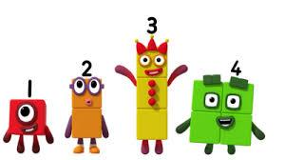  This term children will continue to learn counting skills. They will learn some basic composition of numbers between 1-10. They will look at 3D shapes in the environment and talk about length, height and weight. | The children will have access to our outdoor performance area and learn how to express themselves creatively through the media of music and singing. We will study the artist Giuseppe Arcimboldo.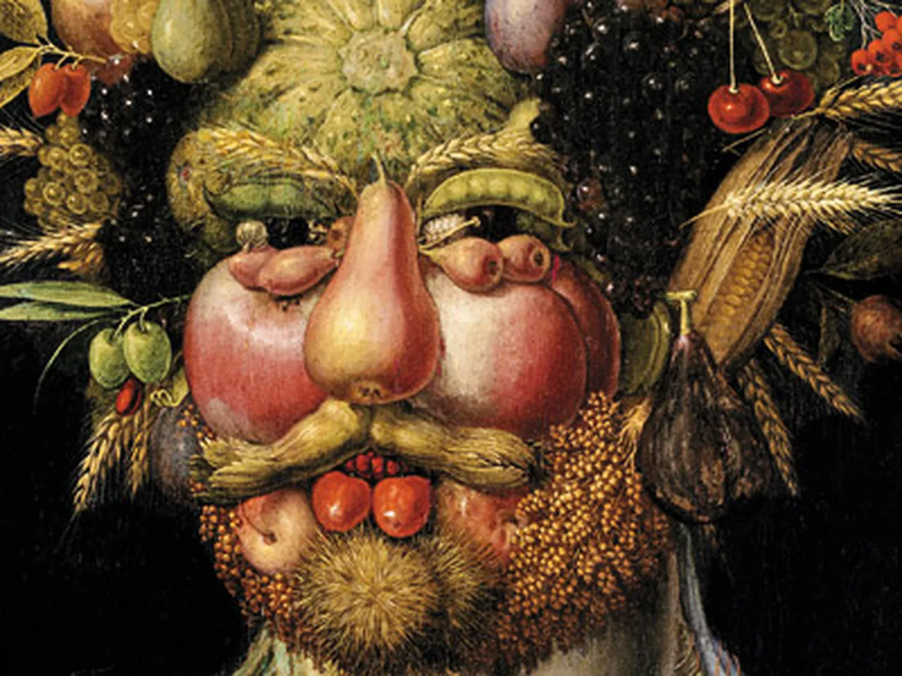
Understanding of the world
The children will learn about different environments around the world. They will discuss similarities and differences. They will learn about space, the planets night and day.
EYFS SpringTerm – summary of learning
Topic: Spring 1- Frozen Lands and Pirates Spring 2- T Infinity and Beyond/ Night and Day
Frozen Lands and Pirates | To infinity and beyond/ Light and Dark

